AP CSP Python with Robots  Design Process and Flowcharts Activity Guide |  | Name:
Activity #1 : The Design Process
What is the design process?
Briefly describe each step of the design process:
Step 1
Step 2
Step 3
Step 4
Step 5
Activity #2 : Flowchart Symbols Give a brief summary of what each flowchart shape is used for.
Activity #3 : Flowcharts
Example #1 Rearrange the flowchart shapes into the correct algorithm.

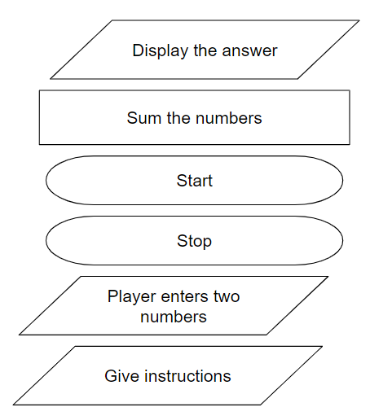

Example #2 Use the correct shapes and rearrange the steps into the correct algorithm:

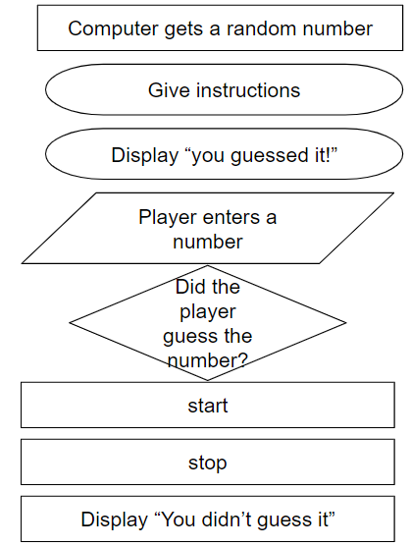

Activity #4 Create flowchart of the program for Mission 3 NavSquare
Activity #5 Create your own flowchart of a daily activity.
Wrap Up:
In your own words, describe an algorithm. |  | In your own words, describe a flowchart.

